Paste the Patient info here

**CURE RANDOMISED CONTROLLED TRIAL SCREENING SHEET**

**Patient Info:**

Ethnicity : ________________________

ICU Admission Date : ________________________

Clinical Diagnostic: ________________________

Initial data, Date and Time: ______________________ (dd/mm/yyyy) _____________________ (am/ pm)

PaO2: ________________________ FiO2: ________________________ SPO2: ________________________

**Inclusion Criteria (Tick if applicable)**

|  |  |
| --- | --- |
|  | 1. Patients requiring invasive mechanical ventilation (intubation or tracheotomy) |
|  | 1. Patients with PF [Oxygen partial pressure to fraction of inspired oxygen] ratio <300mmHg) |
|  | 1. Arterial line in situ. |

**Exclusion Criteria (Tick if applicable)**

|  |  |
| --- | --- |
|  | 1. Patient who are likely to be discontinued from mechanical ventilation within 24 hours. |
|  | 1. Patient with age < 16. |
|  | 1. Patients who have moderate or severe traumatic brain injury, and/or a measured intracranial pressure ≥ 20 cmH2O |
|  | 1. Patients who have a high spinal cord injury with loss of motor function and/ or have significant weakness from any neurological disease. |
|  | 1. Patients who have a Barotrauma (pneumothorax, pneumomediastinum, subcutaneous emphysema or any intercostal catheter for the treatment of air leak). |
|  | 1. Patients who have asthma as the primary presenting condition or a history of significant chronic obstructive pulmonary disease. |
|  | 1. Patients who are moribund and/or not expected to survive for > 72 hours. |
|  | 1. Patients who have already received mechanical ventilation for > 48 hours (including time spent ventilated in a referring unit). |
|  | 1. Lack of clinical equipoise by intensive care unit medical staff managing the patient. |

Is the Patient eligible for CURE Randomised Controlled Trial: Yes No

If Yes, which group is the patient assigned to: Control / Intervention

If No, keep this screening form in the CURE folder.

Fill this portion only after family/ relative/ Whanau has been contacted and informed about CURE Trial

Is the Family/Relative/Whanau consenting to the trial: Yes No Date: ________________________

If Yes, complete consent form.

If No, please remove the patient from trial and update screening form.

Fill this portion only after the patient recovers and patient is informed about the CURE Trial

Is the Patient consenting to the trial: Yes No Date: ________________________

If Yes, complete consent form.

If No, please remove the patient from trial and update screening form.

Updated by: __________________________ (Name) Date:___ ______________________ (dd/mm/yyyy)

**ARDS Definition**

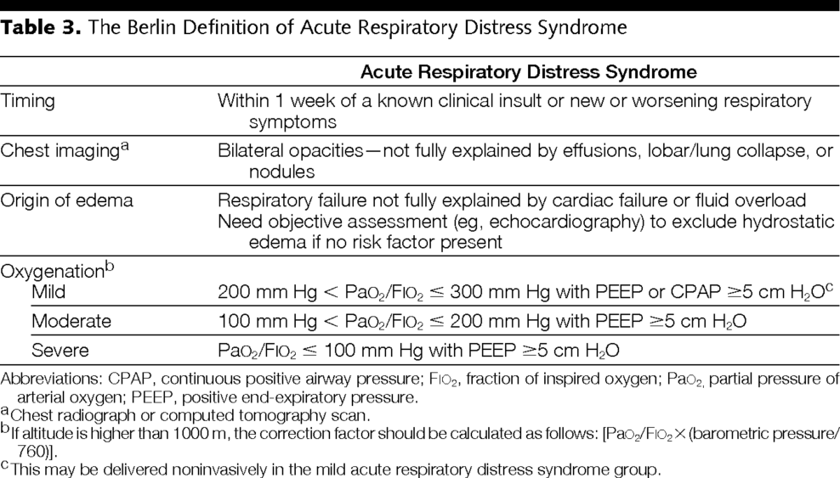

*“Berlin Definition of Acute Respiratory Distress Syndrome”

The ARDS Definition Task Force, A. 2012